**Milestone 5 Customers**

Activity 1: Customers Creation

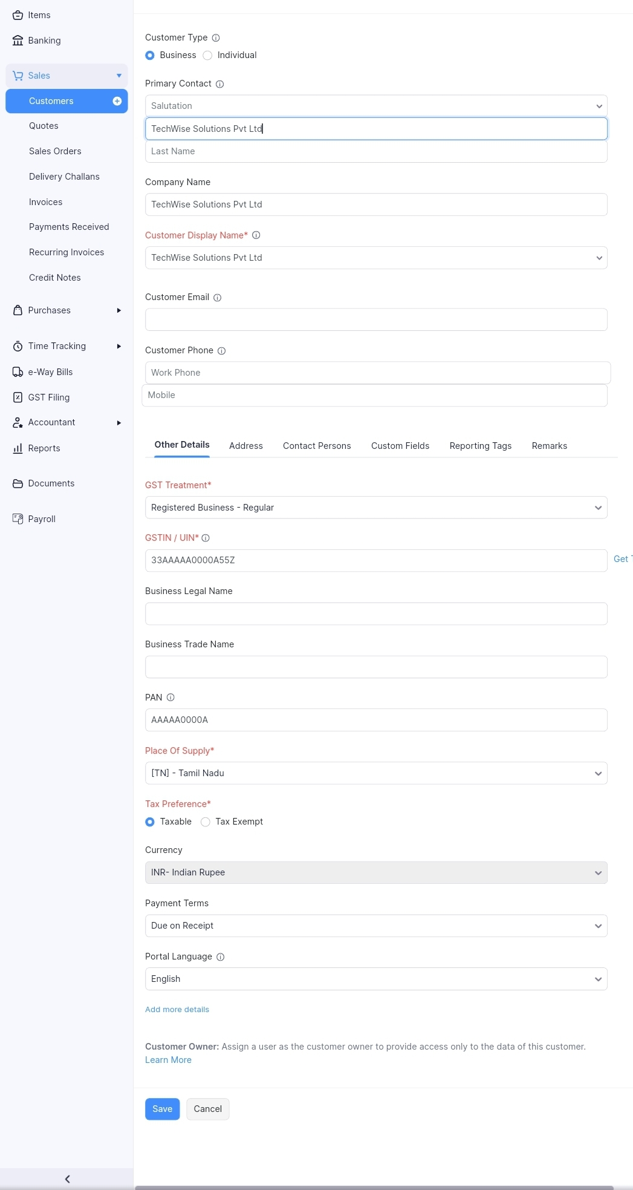

Activity 2: Review the Customers List

